Nader Ahmed
CS469 HW1: Search and Navigation

1) A* Algorithm
A* is a graph search algorithm for finding the shortest path between a start and goal point. It is an improvement to Dijkstra's algorithm,which finds the shortest path from a starting point to all other nodes in a graph. While Dijkstra's considers nodes based on their distance from the start, A* uses a combination of the distance from the start and a heuristic estimate of the distance to the goal.

This heuristic function allows A* to prioritize nodes that seem more promising, leading it to expand on nodes that are more likely to result in a shorter path to the goal. As a result, in many cases, A* can be more efficient than Dijkstra's because it might explore fewer nodes. In order to guarantee optimality, the heuristic must be admissible: it can never overestimate the cost to the goal. If it did, the agent could ignore the optimal path under the guise that it is too costly. With that being said, it should still be a decent estimator. The more that underestimates the distance, the more suboptimal paths it will explore.

For my implementation of A*, the total cost of the cheapest path from start to the goal passing through a node n is f(n)=g(n)+h(n). My cost functions are represented as:

where c represents the cumulative traversal costs. In my implementation, I experiment with both the Chebyshev and Euclidean distances for my heuristic functions:

Both heuristics underestimate the distance to the goal; the Chebyshev only takes the distance of the higher coordinate dimension difference, and the Euclidean is scaled down. Thus, both are admissible.

For the purposes of this assignment, I define two sets of points to be used while plotting paths:

1b) Offline A* Planned Paths

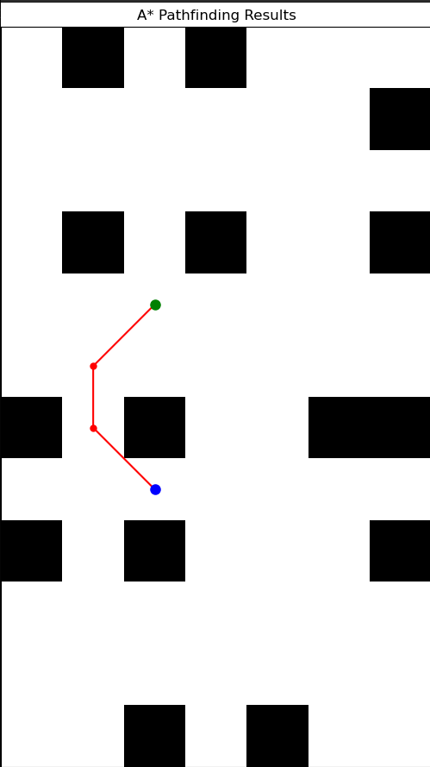 S = [0.5, -1.5], G = [0.5,1.5] | 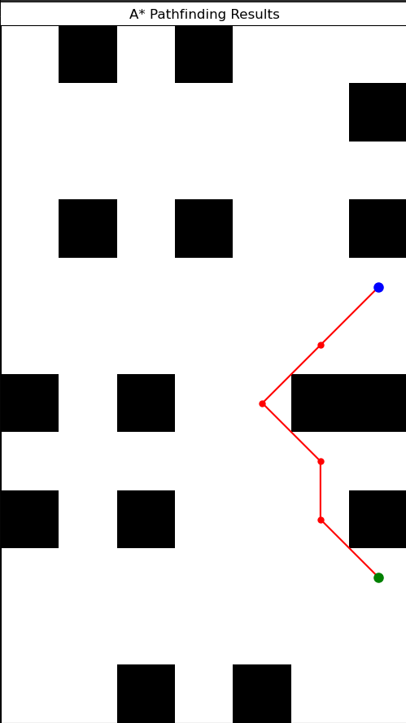 S =[ 4.5, 3.5 ], G=[ 4.5,−1.5 ] | 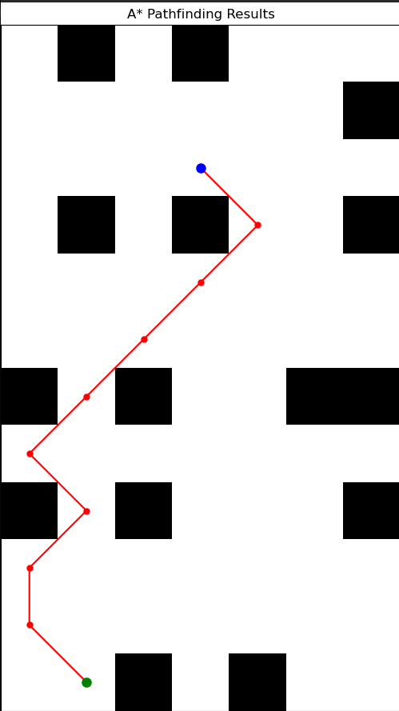 S=[−0.5, 5.5 ], G=[ 1.5,−3.5 ]
Figure 1: Offline A* Performance on Set 1 Points. Red: Computed Path, Blue: Start point, Green: Goal point

2) Online A*

The offline version of A* runs until the goal node is found and then chooses the most optimal path from start to goal. This naturally assumes that the agent has full observability of the environment. In this case, every neighbor is added to the frontier. Since the minimum cost node in the frontier is selected for expansion, the agent effectively jumps to expand nodes within the relatively large frontier.

The online version of A* assumes that a mobile differential robot with partial observability does not have this capability. Since the robot has no prior knowledge of the environment, it adds only the single best neighbor to the frontier during each iteration. This simplifies its decision-making, but limits its view of potential nodes to expand. Consequently, when the robot does reach the goal, its path length may be longer as it can visit suboptimal nodes during its exploration.

2) Online A* Planned Paths

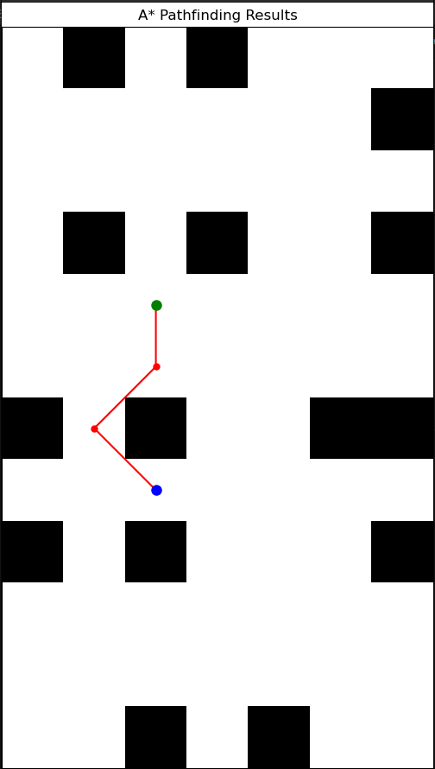 S = [0.5, -1.5], G = [0.5,1.5] | 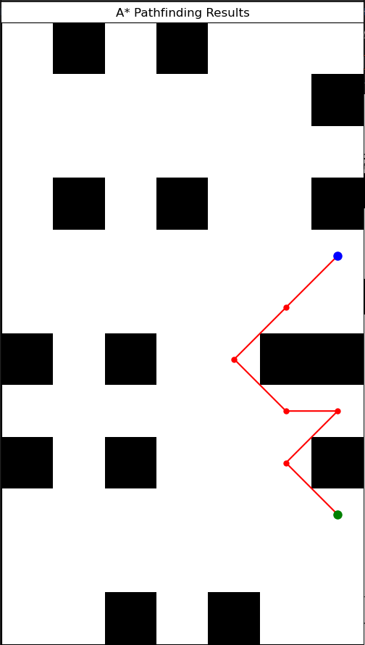 S =[ 4.5, 3.5 ], G=[ 4.5,−1.5 ] | 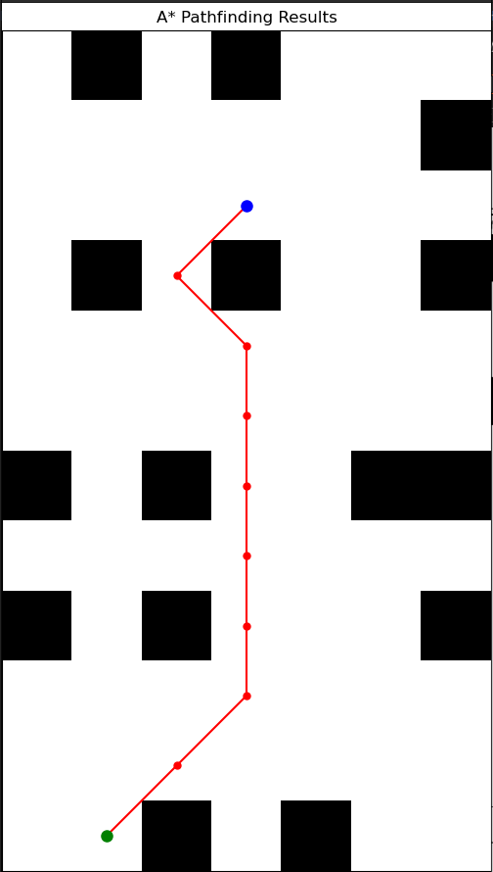 S=[−0.5, 5.5 ], G=[ 1.5,−3.5 ]
Figure 2: Online A* performance on set 1 points. Red: computed Path, blue: start point, green: goal point

2c) Decreasing cell sizes to .1 x .1m

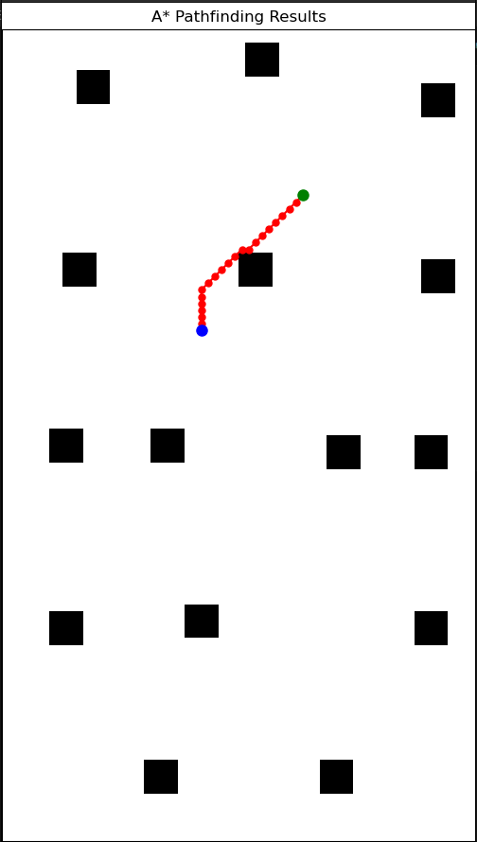S=[2.45,−3.55],G=[0.95,−1.55] | 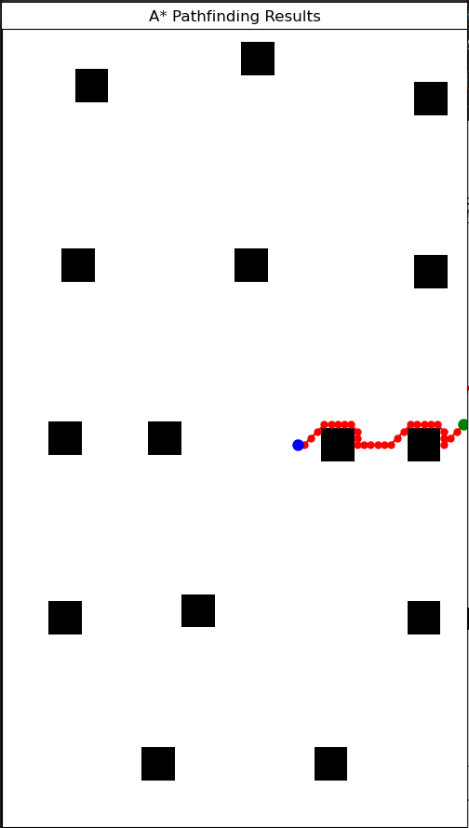S=[4.95,−0.05] ,G=[2.45, 0.25] | 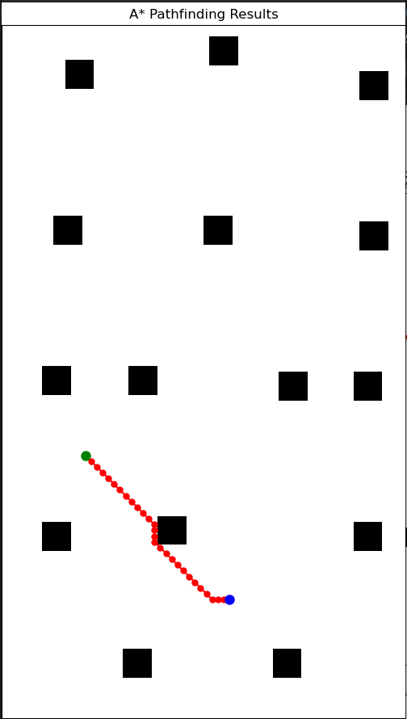S=[−0.55, 1.45],G=[1.95, 3.95]
Figure 3: Online A* performance on set 2 points with decreased cell sizes and inflated landmarks.
Red: computed path, blue: start point, green: goal point.

3) Inverse Kinematic Controller

An inverse kinematic controller is used to drive the paths generated by online A*. It outputs a command to the agent consisting of a translational and rotational velocity. A proportional controller is used to determine the velocities based on the error signal between the desired and current position.

The controller also stores the previously generated command at all times in order to impose acceleration limits. If either the linear or angular velocities exceed the given maximums, the velocities are clipped as follows:

Moreover, a motion model is used to keep track of the robot’s position and heading after these velocity commands are sent. By adding noise, the model assumes that there is some disparity between the commanded and actual velocities:

3b) Online planned paths from using controller
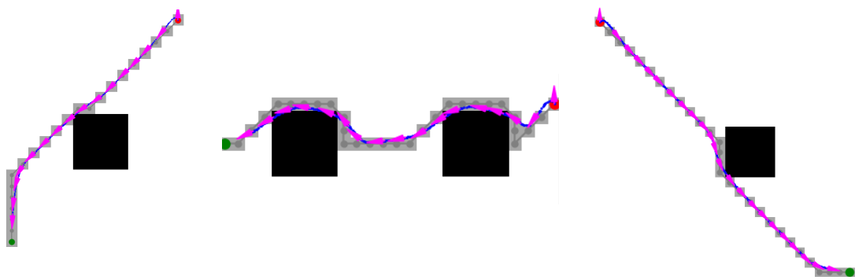
Figure 4: Driven paths from set 2 using the inverse kinematic controller.
Pink: heading, red: start, green: goal, blue: driven path, gray: complete A* path.

Driving the paths generated by my online A* algorithm was relatively successful. One challenge was determining the appropriate constants for the proportional controller. With low constants, the agent drove smoothly around the path but oscillated around it. With high constants, the agent drove in an extremely jagged manner. Despite the chaotic path shown in Figure 5, the agent did actually reach all of the path points. Overall, the controller was quite sensitive to small changes.

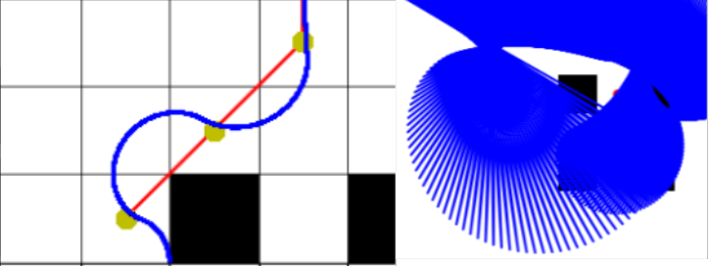

Figure 5: Driven paths with different proportional constants.
Left: Right:

Moreover, determining the weighting between both constants was difficult. Through trial and error, I found to work very well. For more the coarser grids, higher constants generally fared better.\

3c) Planning set 2 paths while driving them
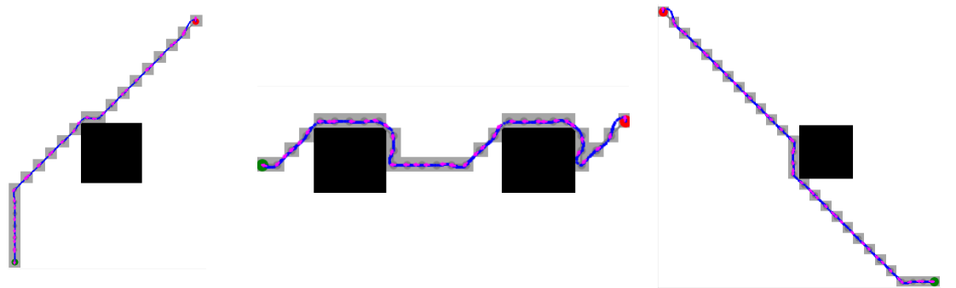
Figure 6: Driven paths from set 2, now planning while moving
Pink: heading, red: start, green: goal, blue: driven path, gray: complete A* path.

3d) Planning set 1 paths while driving them on the finer grid.
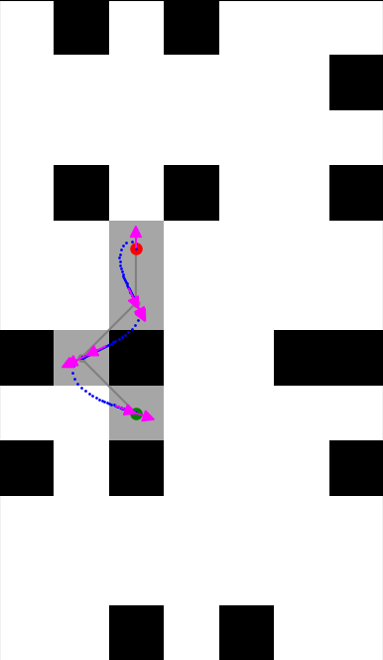 | 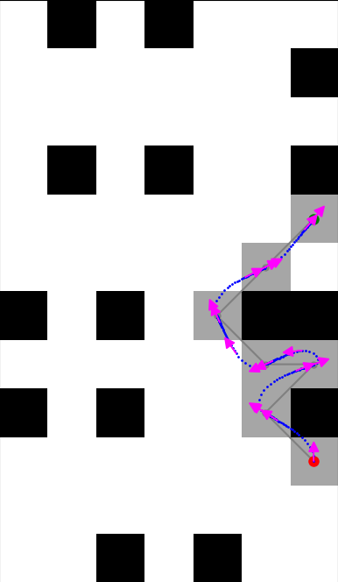 | 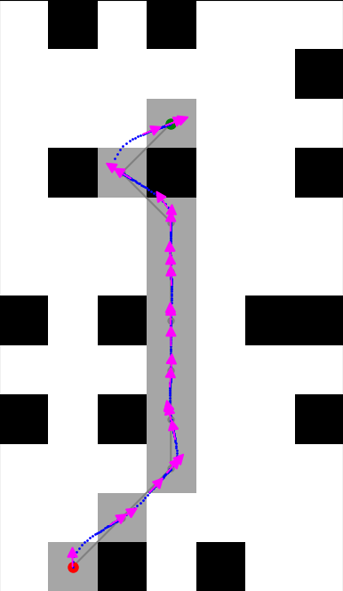

3e) Planning set 1 paths while driving them on coarser grid

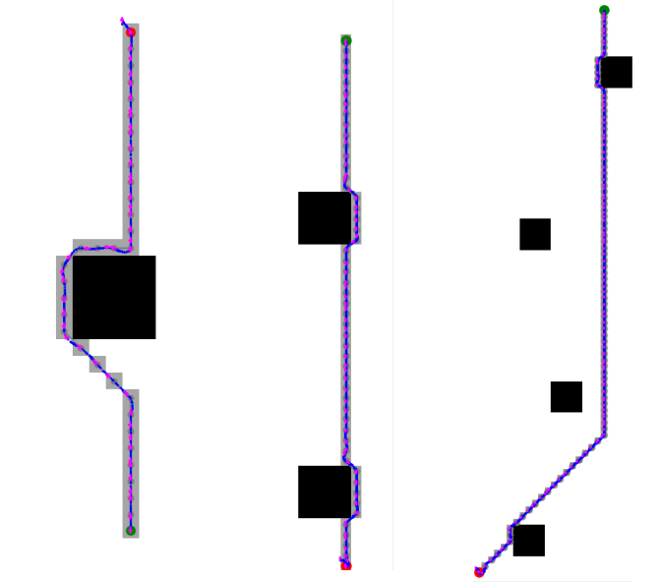

3e) Controller assumptions

